Perancangan Aplikasi

Pelaporan Pengaduan Masyarakat

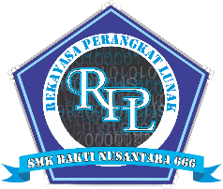

Mirza Qamaruzzaman  
(202114070056)

Uji Kompetensi Keahlian

Rekayasa Perangkat Lunak

SMK BAKTI NUSANTARA 666

2023

**DAFTAR ISI**

1. **USE CASE DIAGRAM 3**
2. **CLASS DIAGRAM 4**
3. **ACTIVITY DIAGRAM 5**
4. Activity Diagram Login 5
5. Activity Diagram Registrasi Masyarakat 5
6. Activity Diagram Administrator 6
7. Activity Diagram Masyarakat 7
8. Activity Diagram Petugas 8
9. **SEQUENCE DIAGRAM 9**
10. Sequence Diagram Login 9
11. Sequence Diagram Masyarakat 10
12. Sequence Diagram Administrator 11
13. Sequence Diagram Petugas 12
14. **MOCKUP DESIGN 13**
15. Halaman Login 13
16. Halaman Register 13
17. Landing Page Guest 14
18. Landing Page Masyarakat 15
19. Landing Page Admin & Petugas 16
20. Halaman Seluruh Pengaduan 17
21. Halaman Pengaduan Saya (Masyarakat) 18
22. Halaman Detail Pengaduan 19
23. Halaman Profil Masyarakat 20
24. Halaman Ubah Profil Masyarakat 21
25. Halaman Dashboard Petugas 22
26. Halaman Dashboard Administrator 22
27. Halaman List Pengaduan Menunggu 23
28. Halaman List Pengaduan Diproses 23
29. Halaman List Pengaduan Selesai 24
30. Halaman Detail Pengaduan 24
31. Halaman Profil Admin & Petugas 25
32. Halaman Menagement Petugas (Administrator) 25
33. Halaman Management Masyarakat (Administrator) 26
34. **USE CASE DIAGRAM**

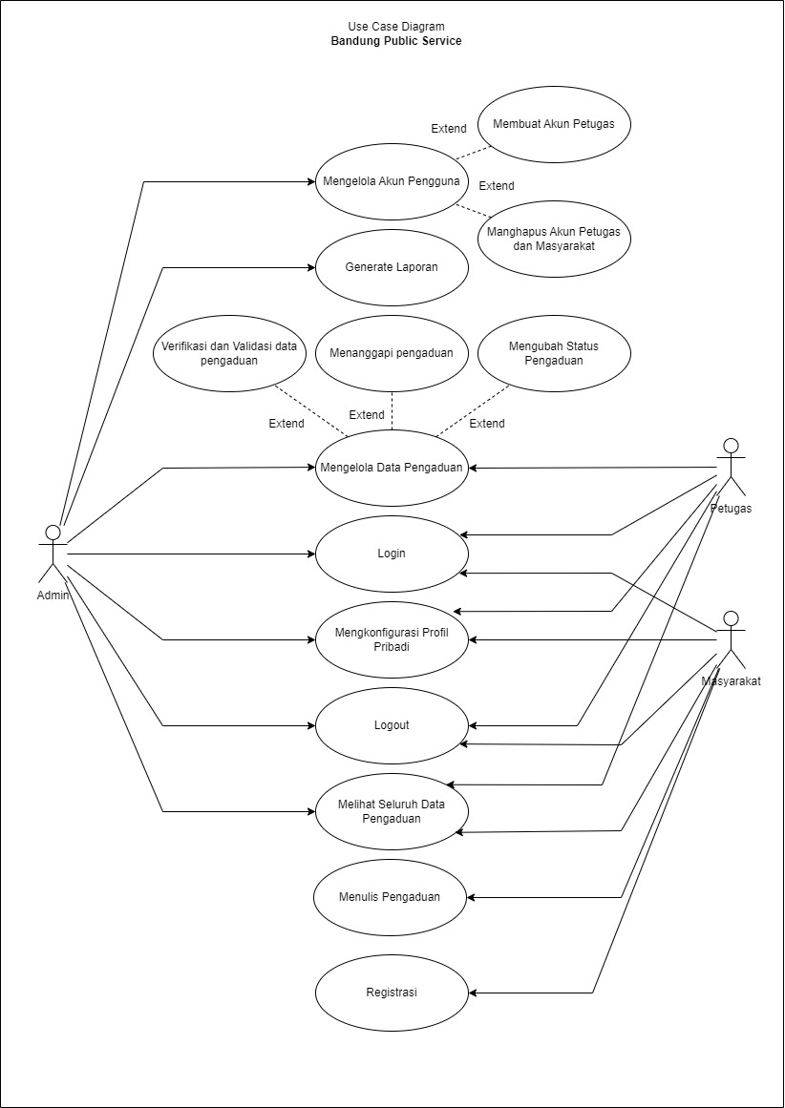

1. **CLASS DIAGRAM**

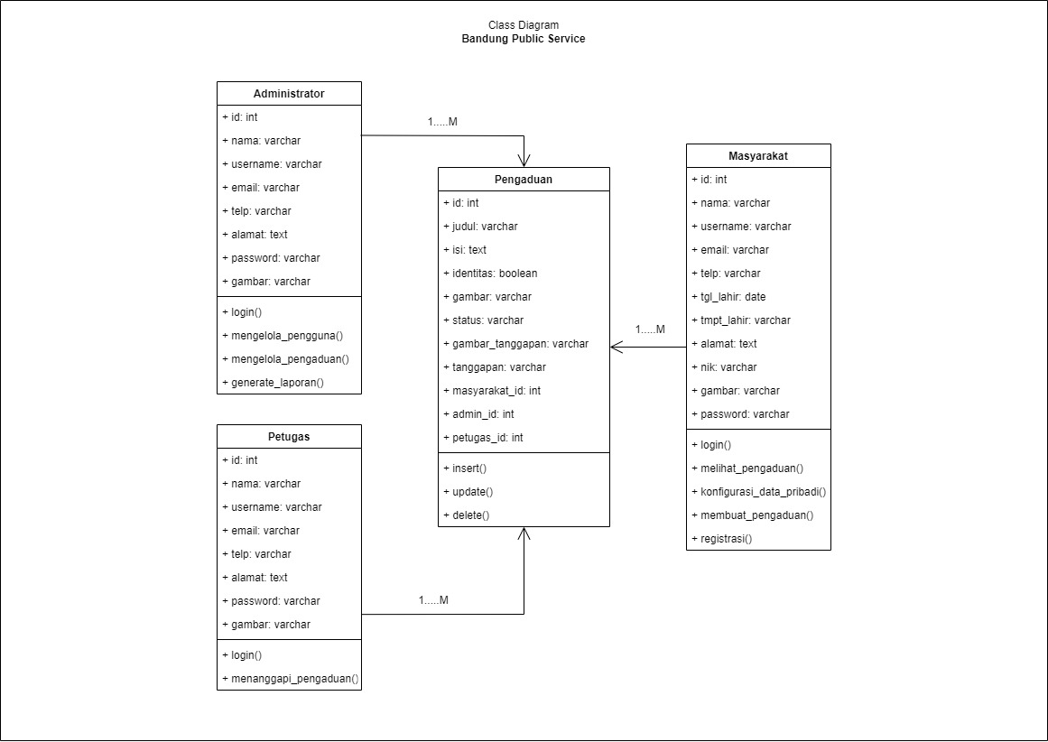

1. **ACTIVITY DIAGRAM**
2. Activity Diagram Login

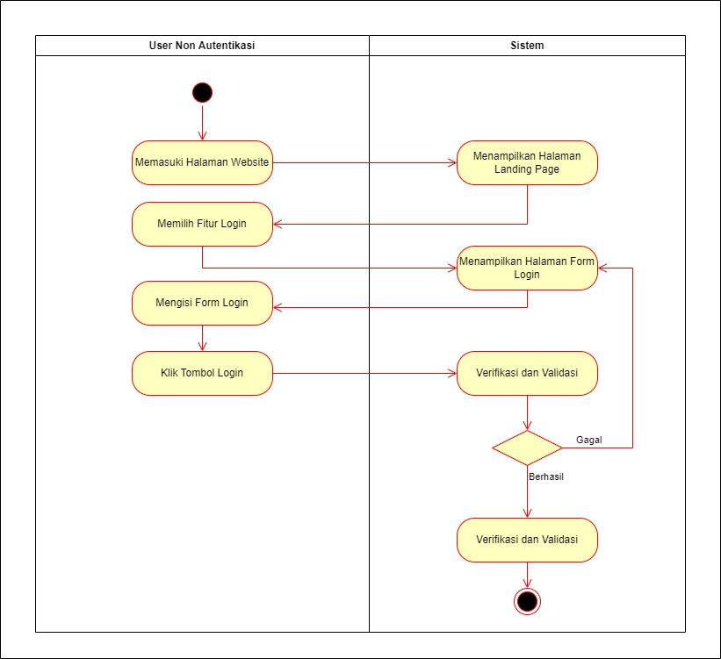

1. Activity Diagram Registrasi Masyarakat

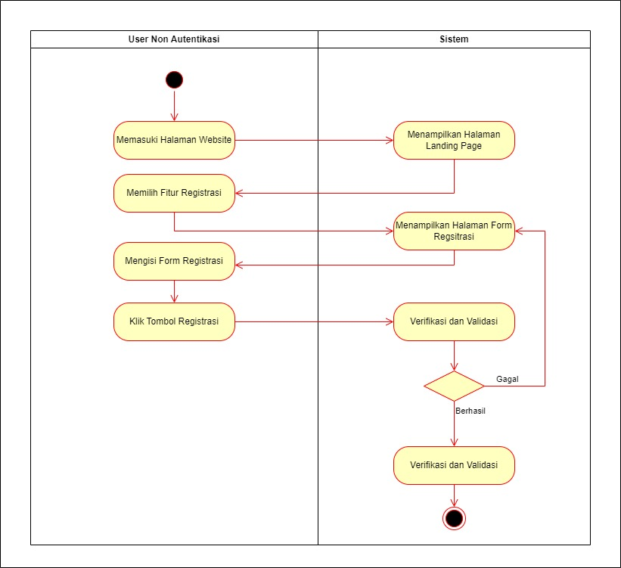

1. Activity Diagram Administrator

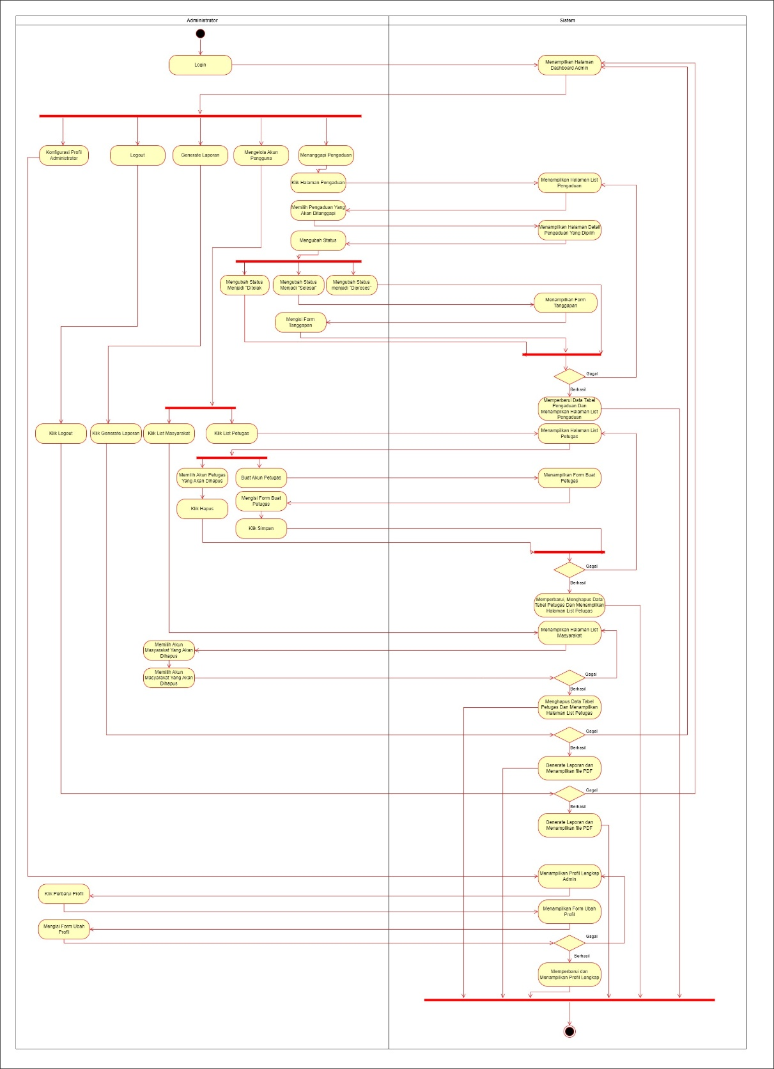

1. Activity Diagram Masyarakat

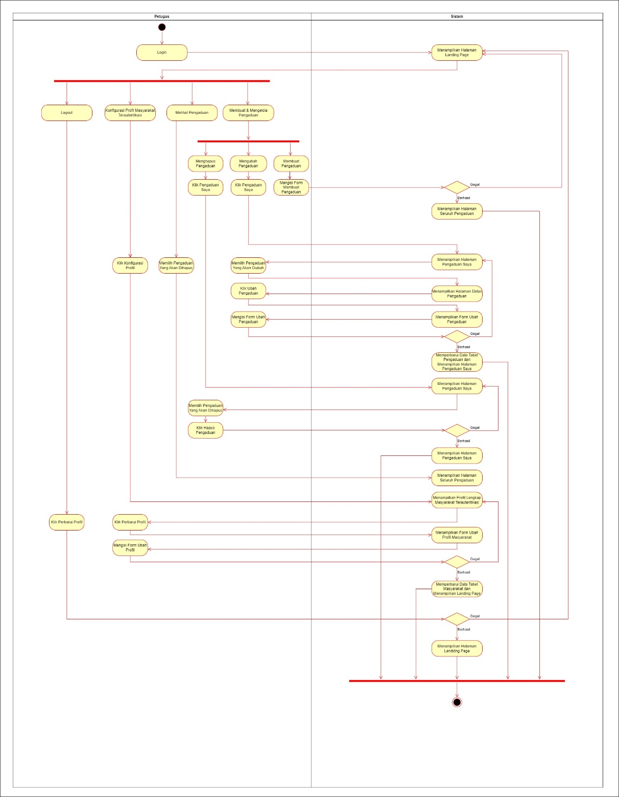

1. Activity Diagram Petugas

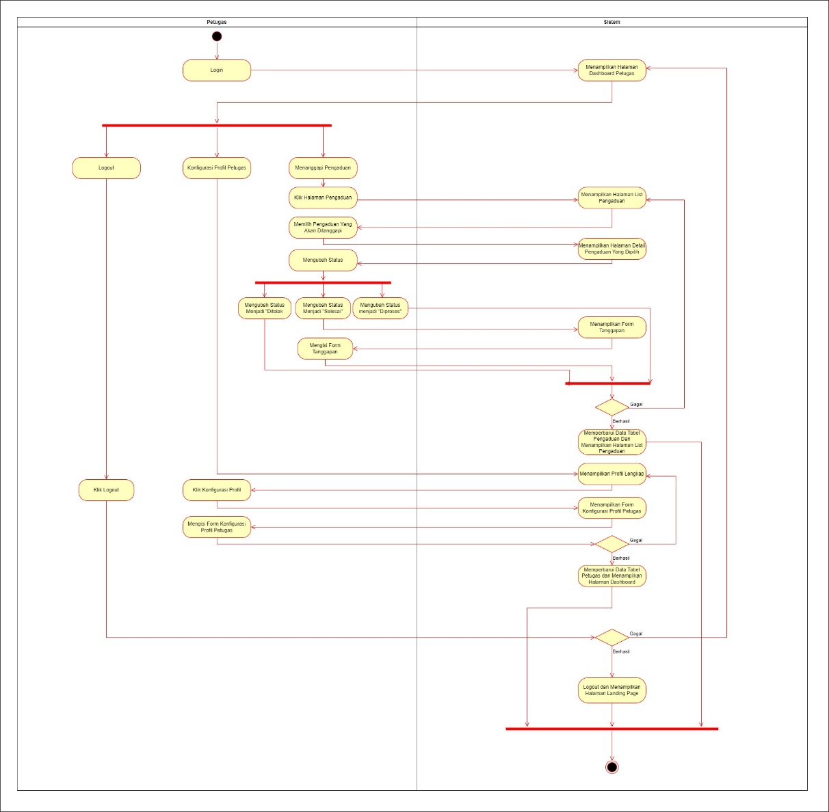

1. **SEQUENCE DIAGRAM**
2. Sequence Diagram Login

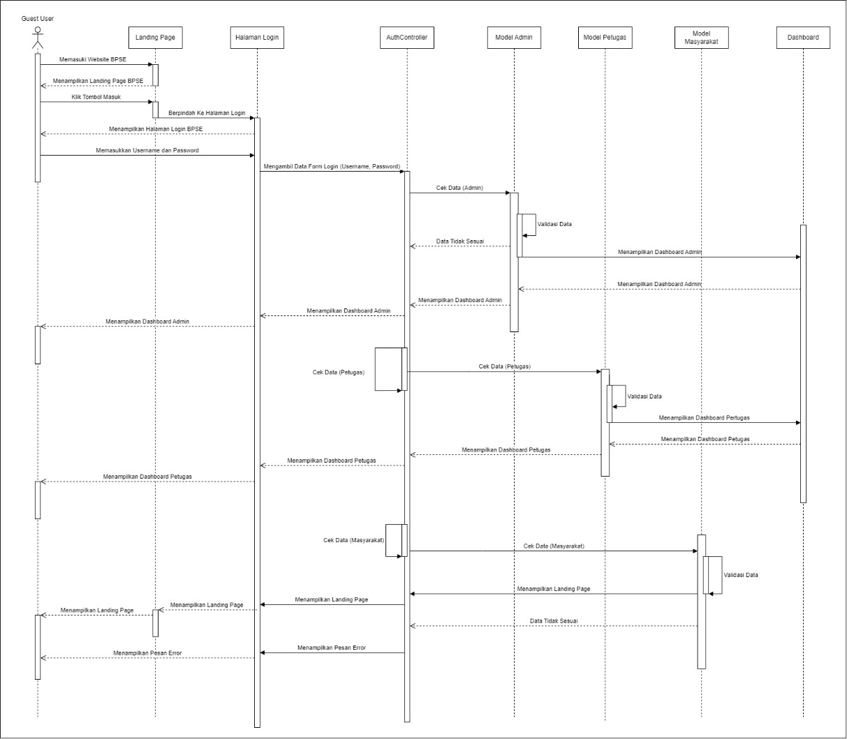

1. 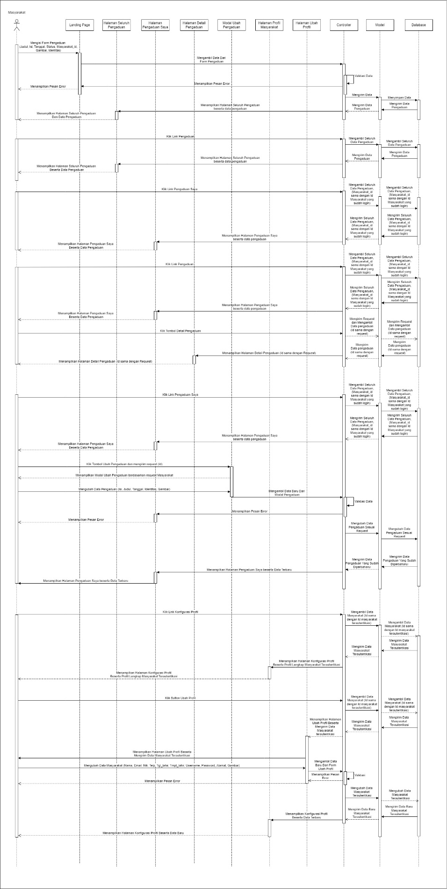Sequence Diagram Masyarakat
2. Sequemce Diagram Administrator

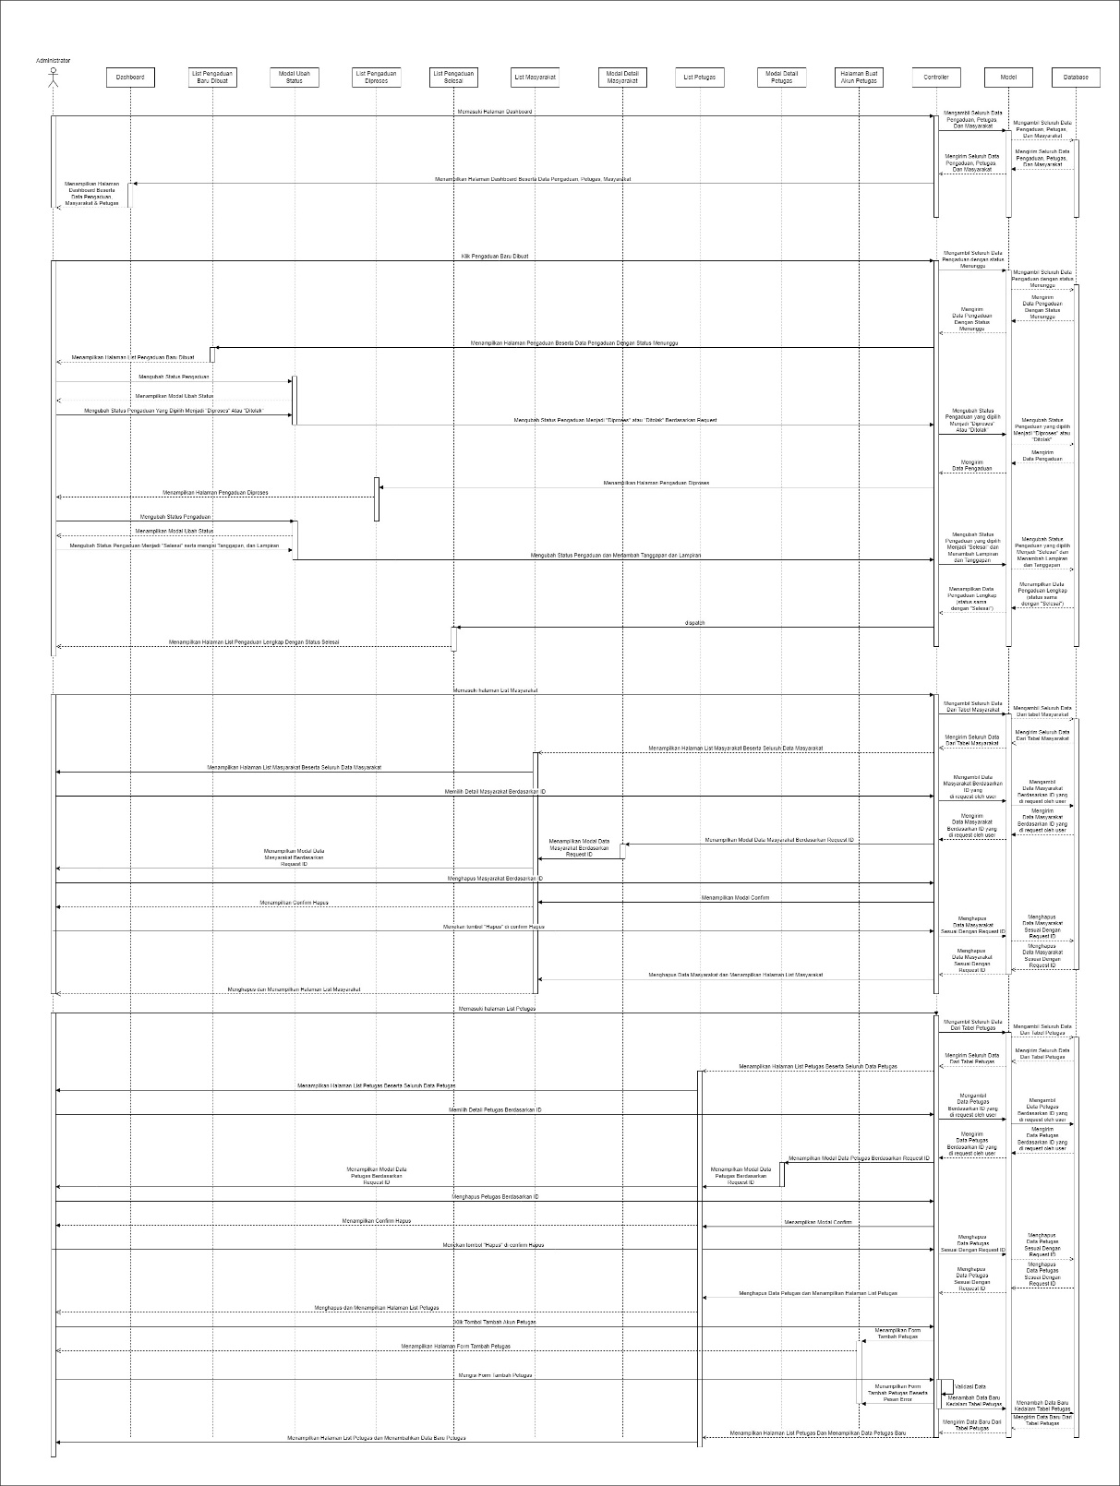

1. Sequence Diagram Petugas

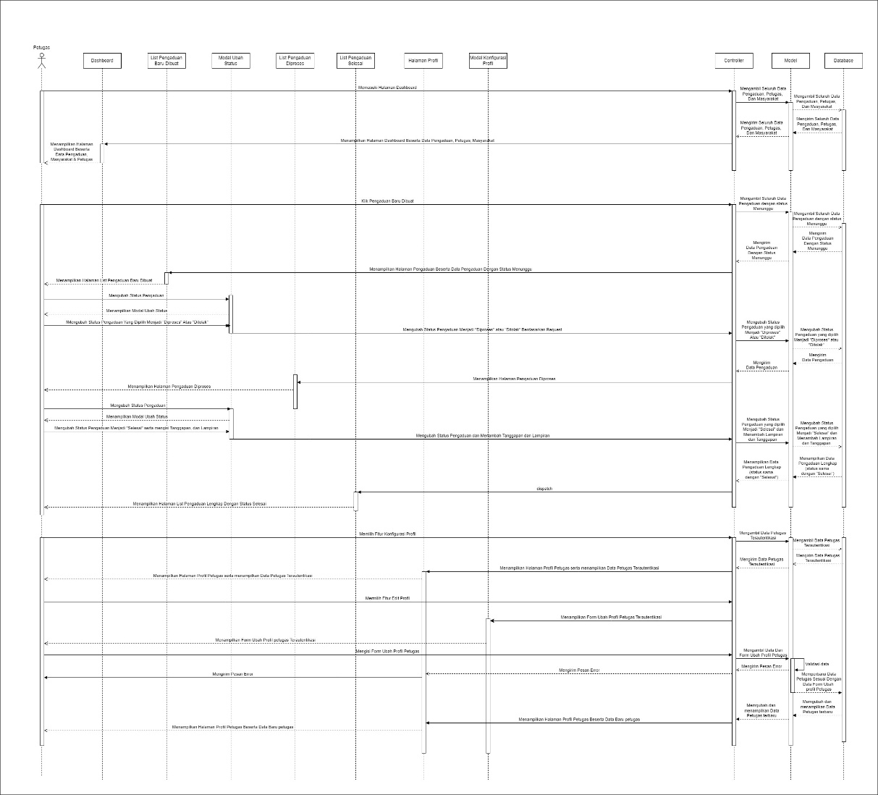

1. **MOCKUP DESIGN**
2. 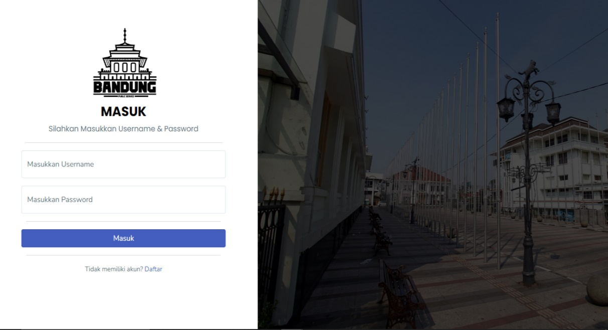Halaman Login
3. Halaman Register

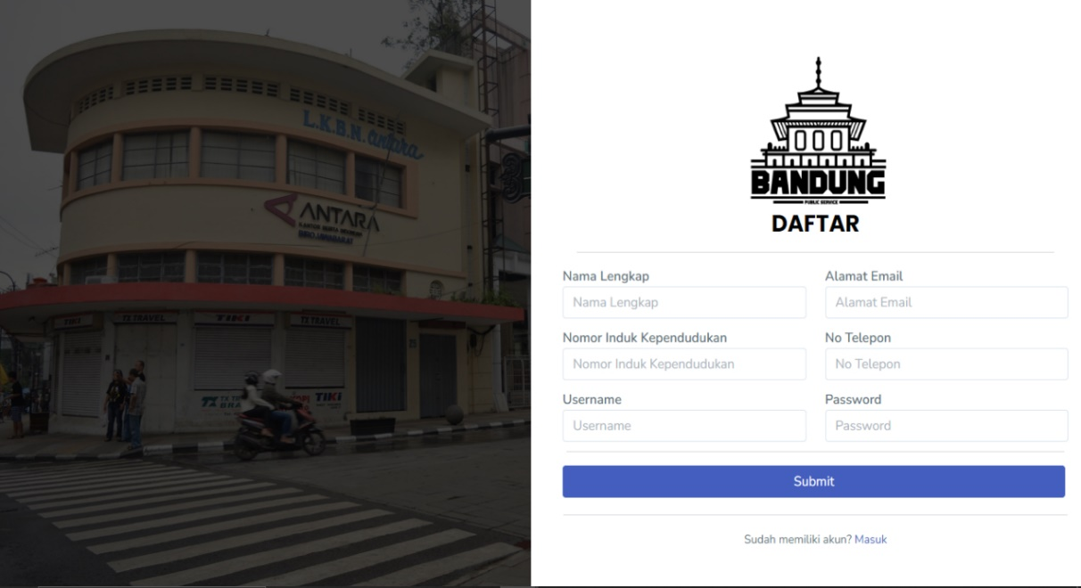

1. 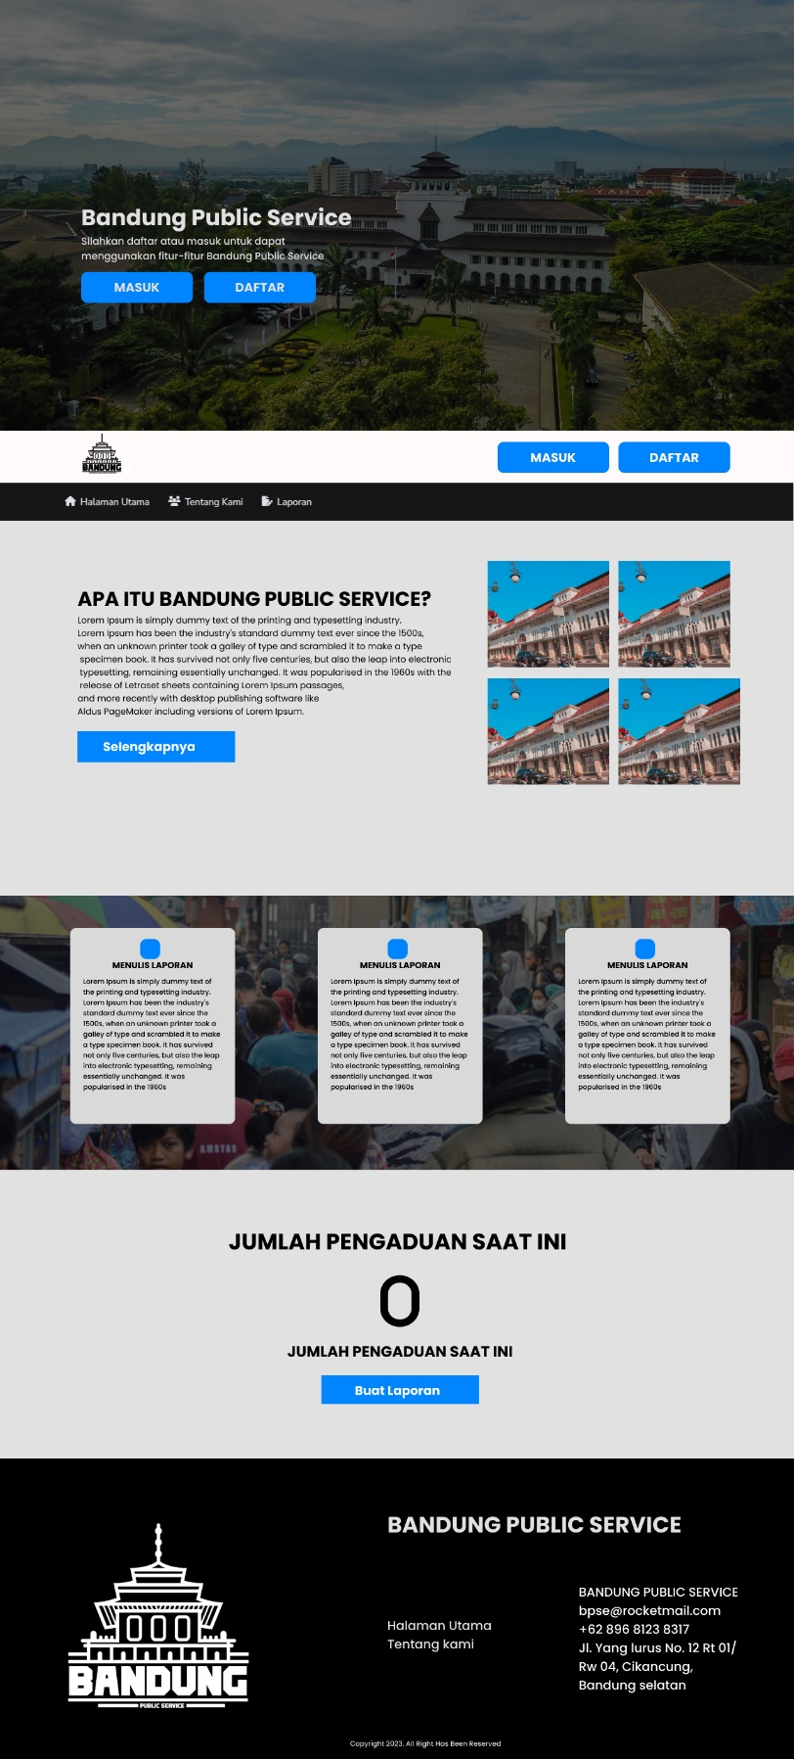Landing Page Guest
2. Landing Page Masyarakat

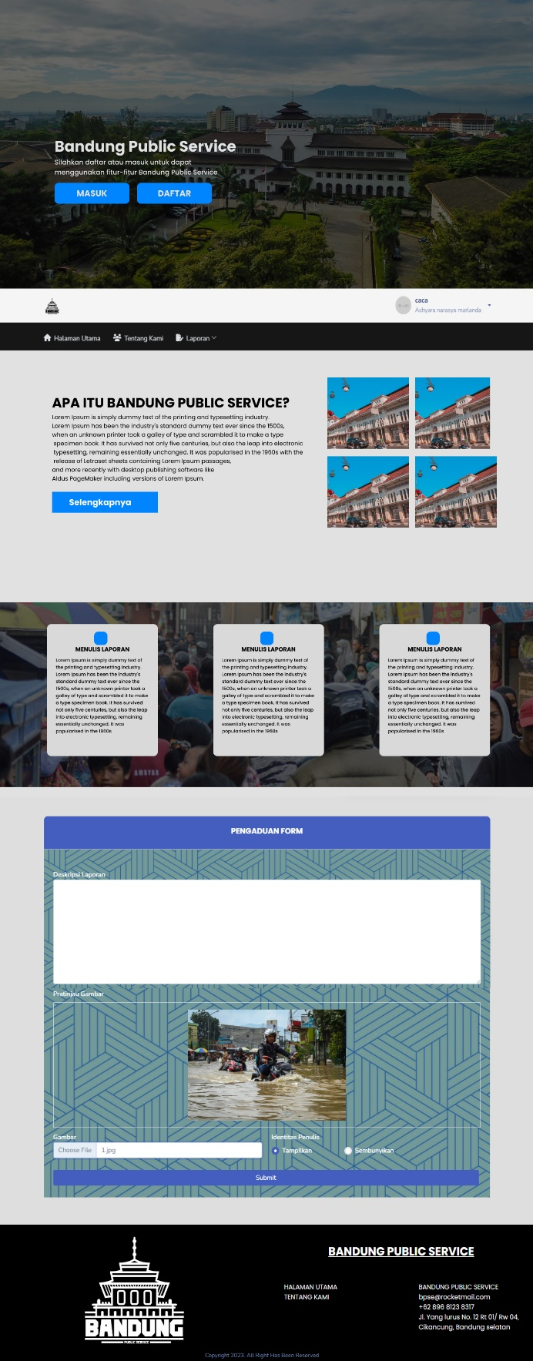

1. Landing Page Admin Dan Petugas

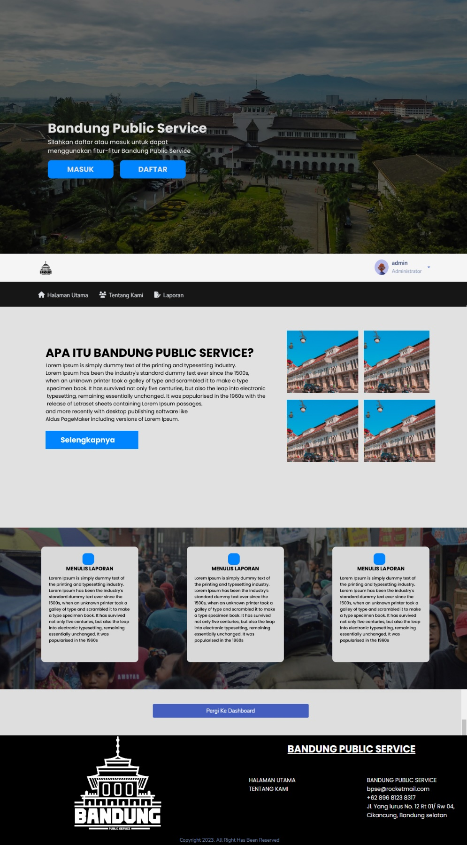

1. Halaman Seluruh Pengaduan

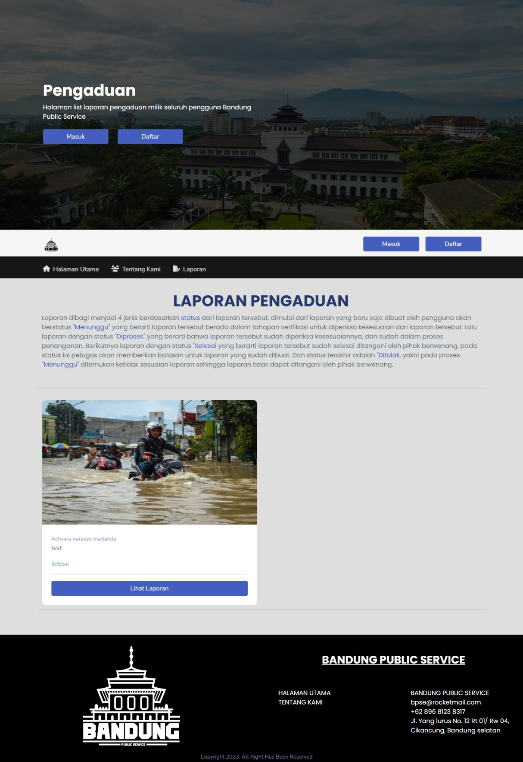

1. Halaman Pengaduan Saya (Masyarakat)

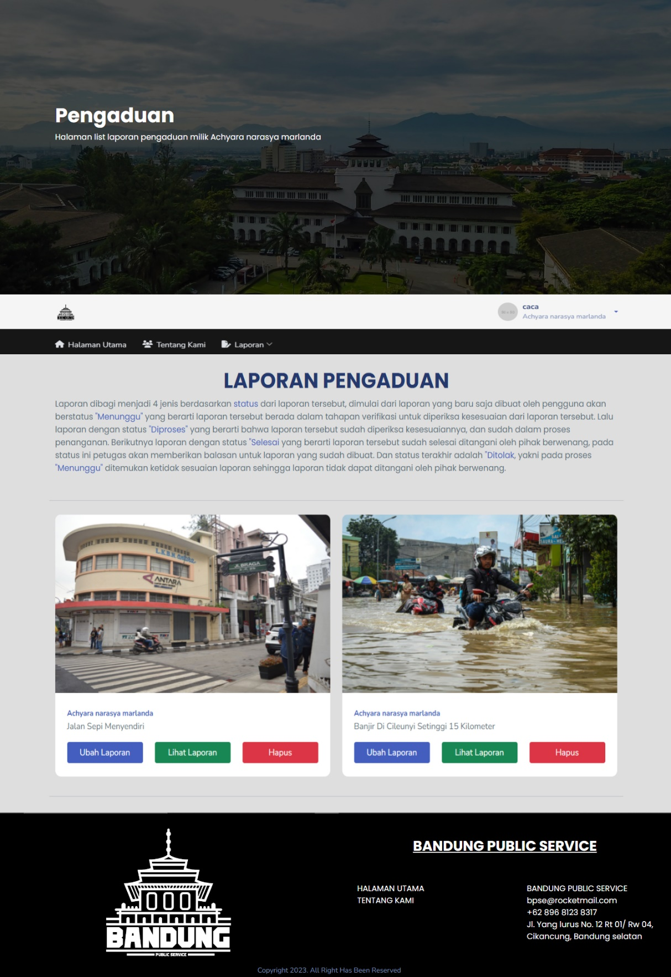

1. Halaman Detail Pengaduan

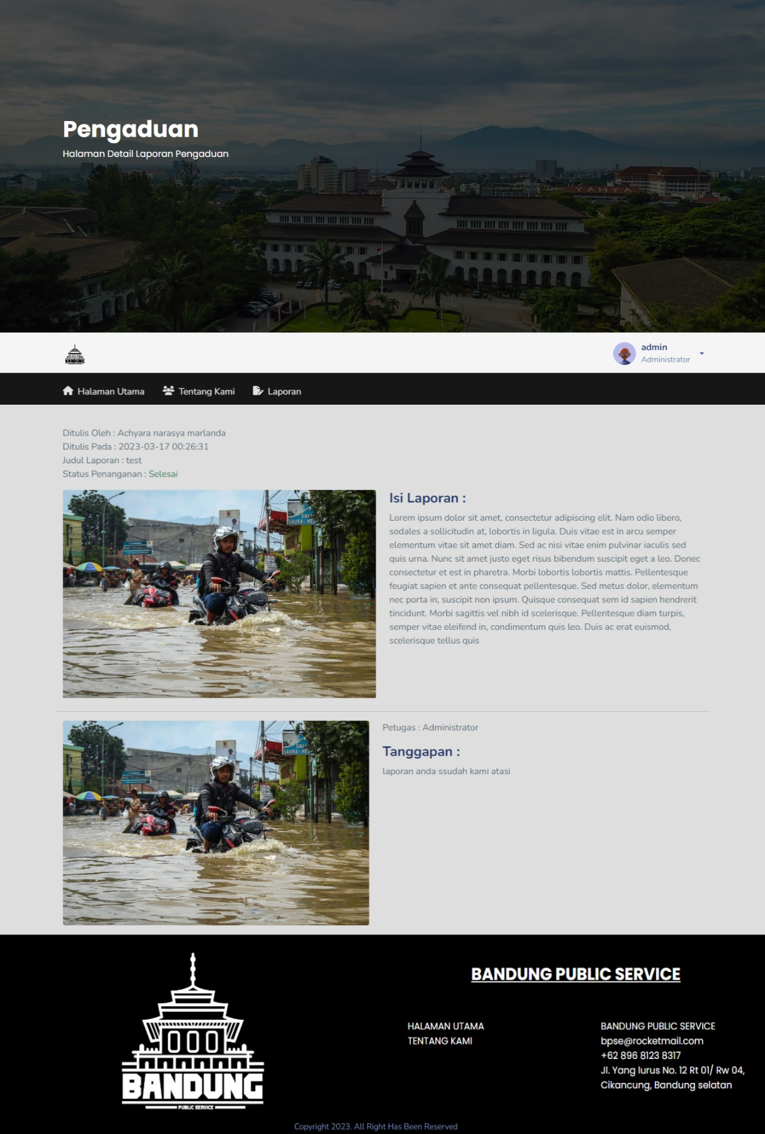

1. Halaman Profil Masyarakat

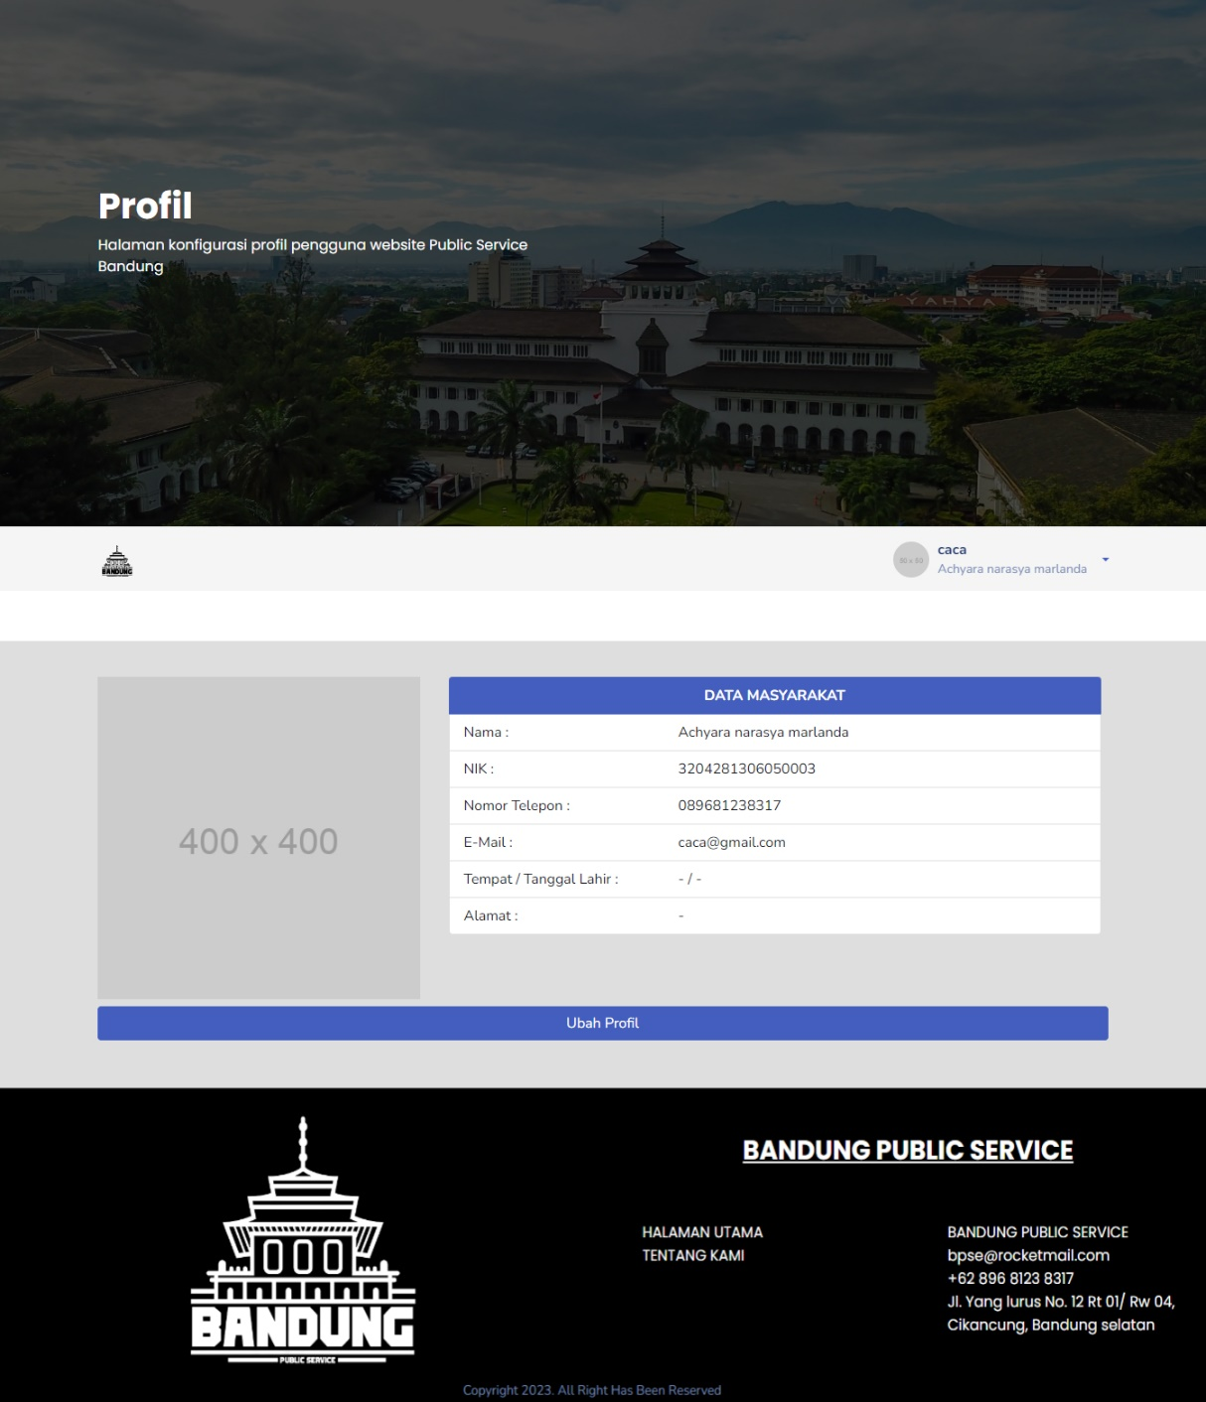

1. Halaman Ubah P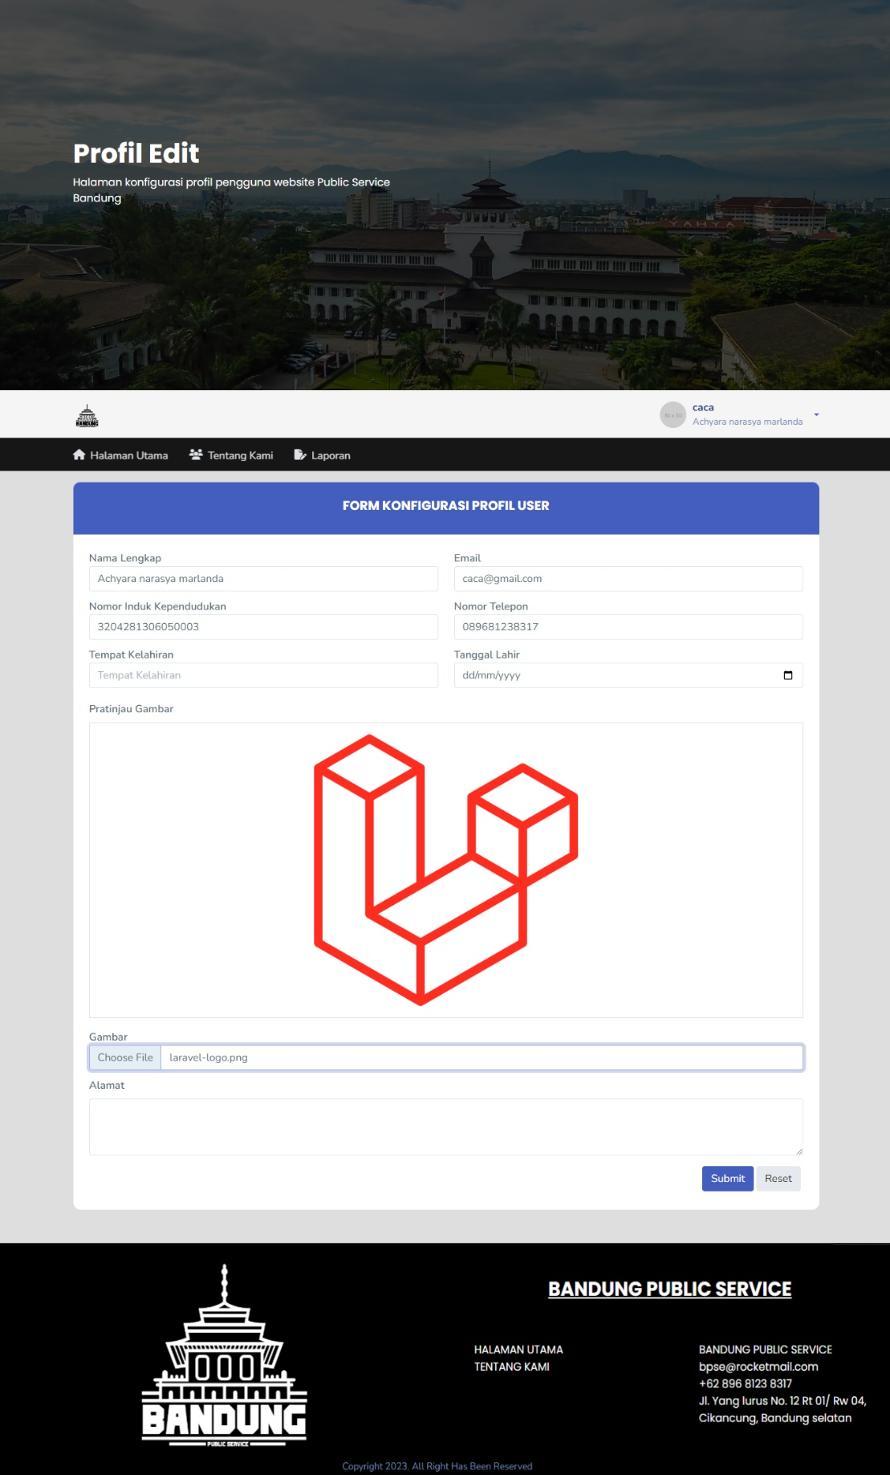rofil Masyarakat
2. Halaman Dashboard Petugas

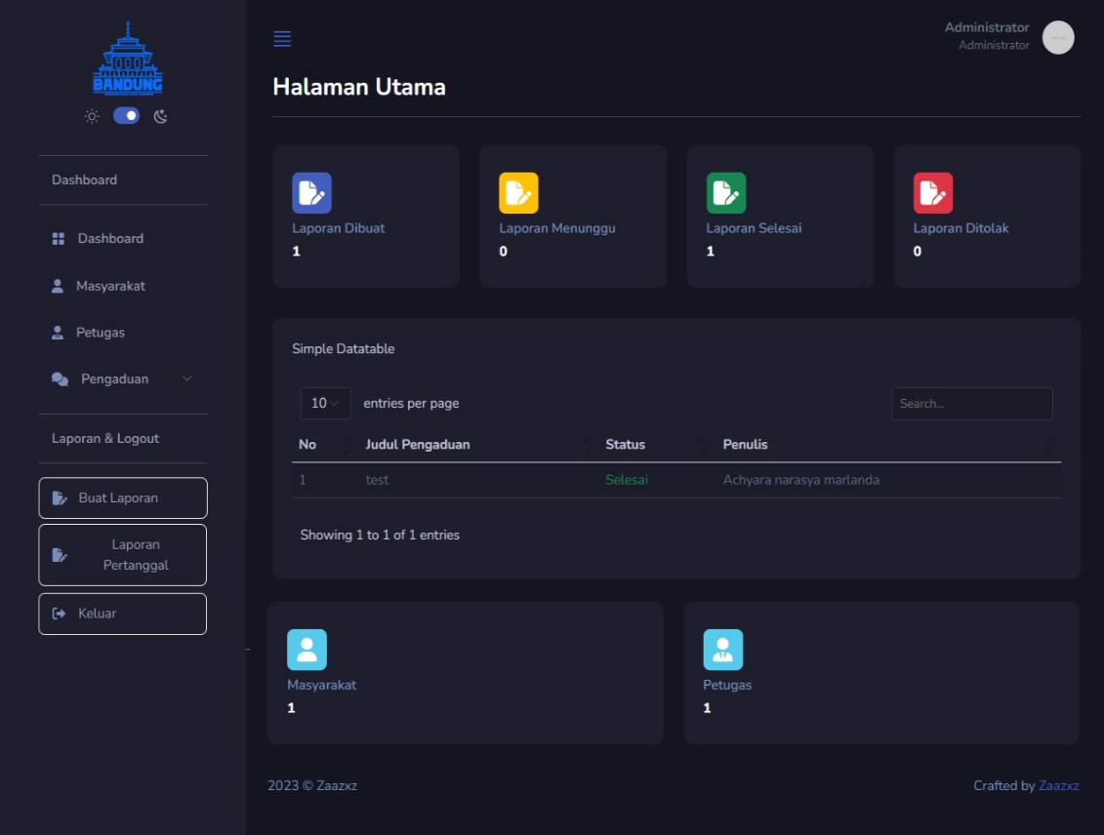

1. 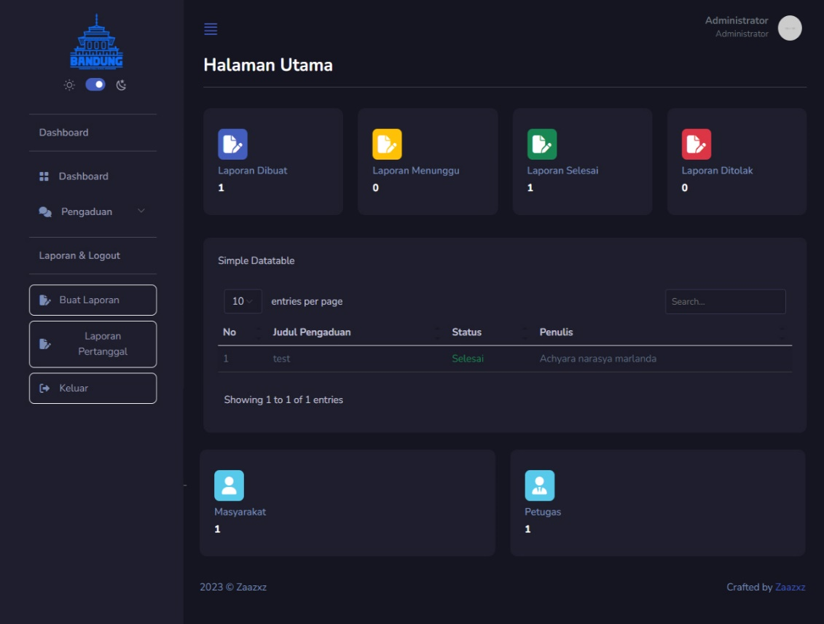Halaman Dashboard Administrator
2. 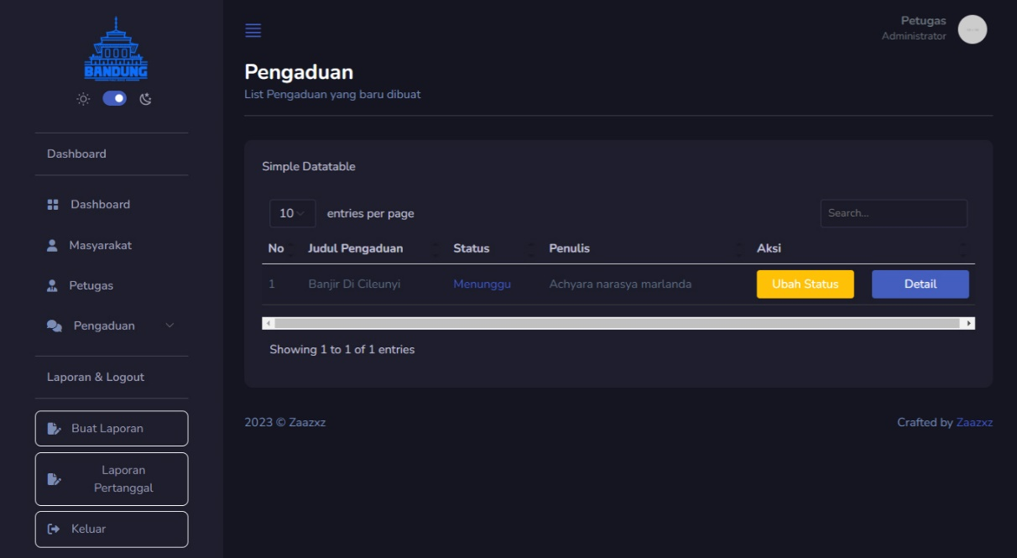Halaman List Pengaduan Menunggu
3. 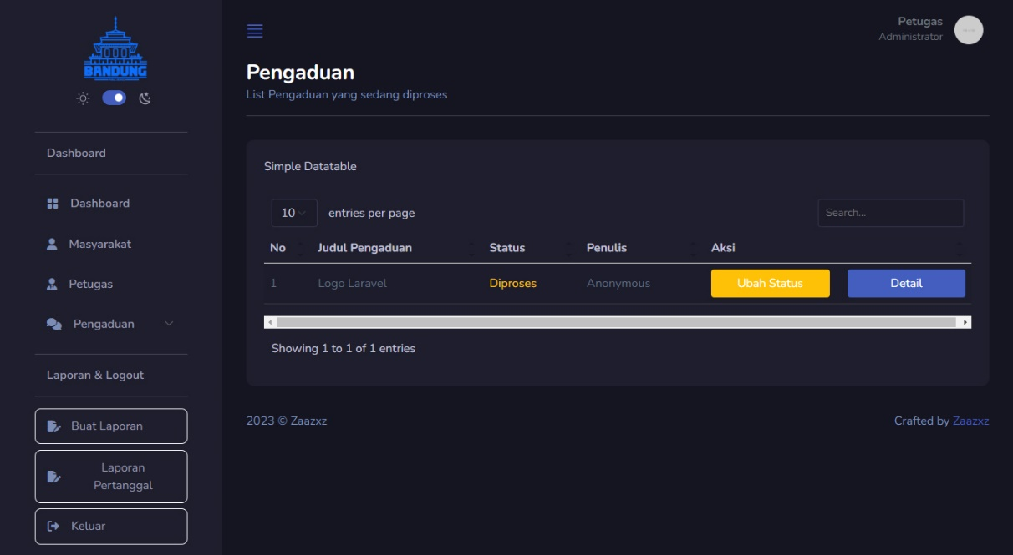Halaman List pengaduan Diproses
4. 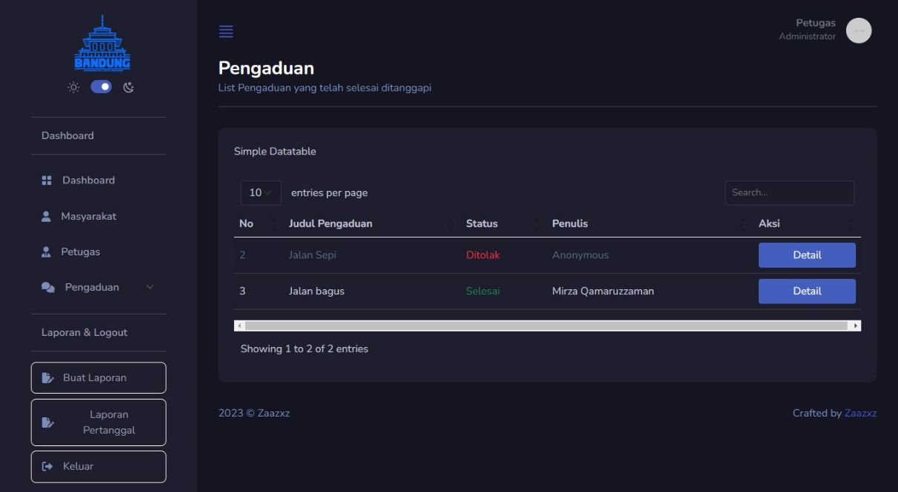Halaman List Pengaduan Selesai
5. 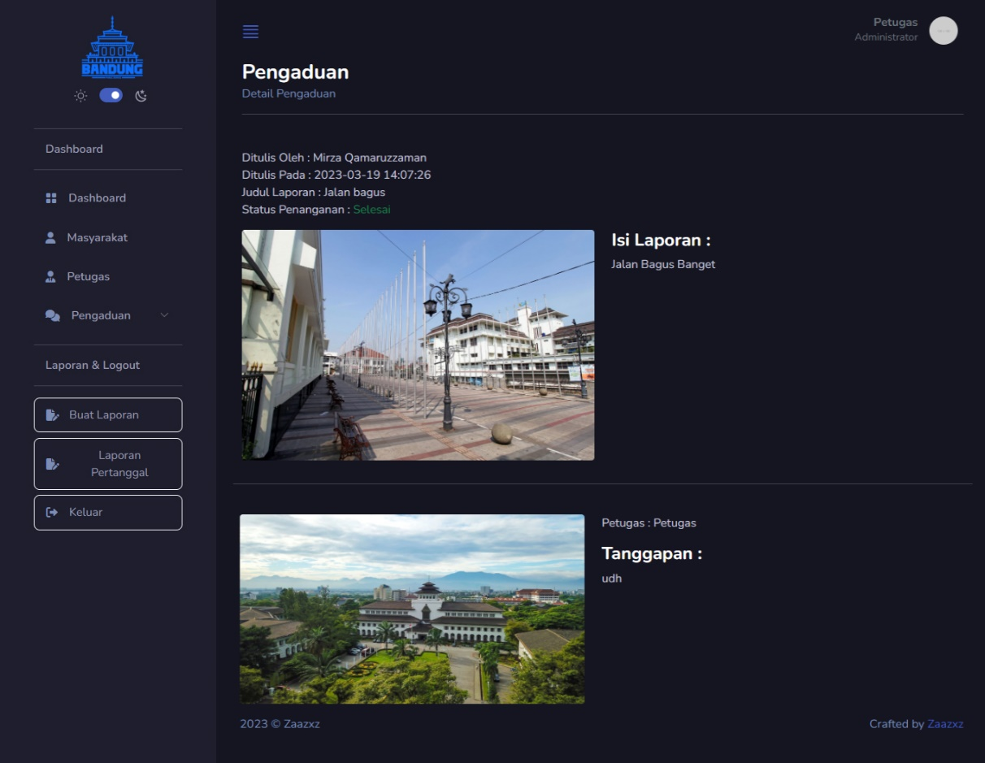Halaman Detail Pengaduan
6. 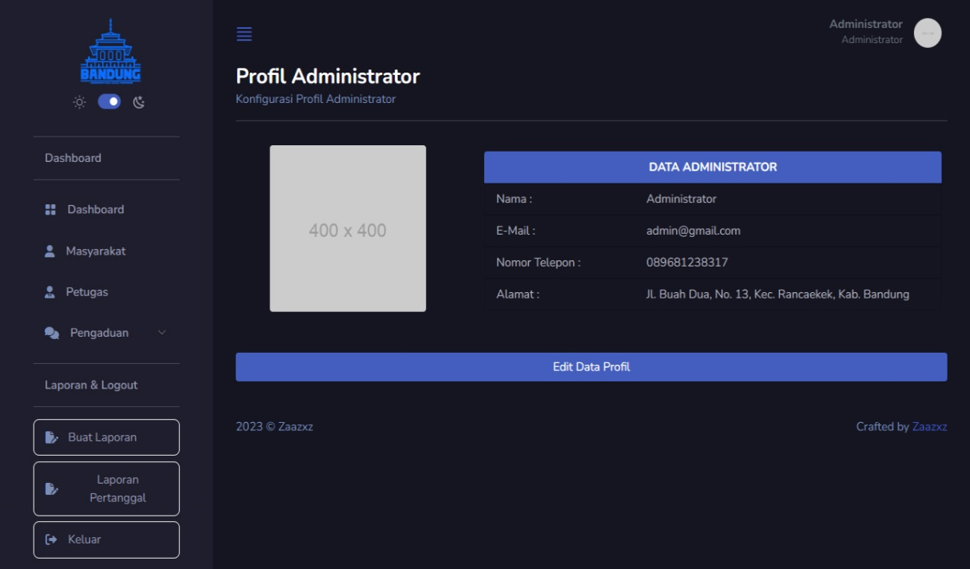Halaman Profil Admin dan Petugas
7. Halaman Management Petugas (Administrator)

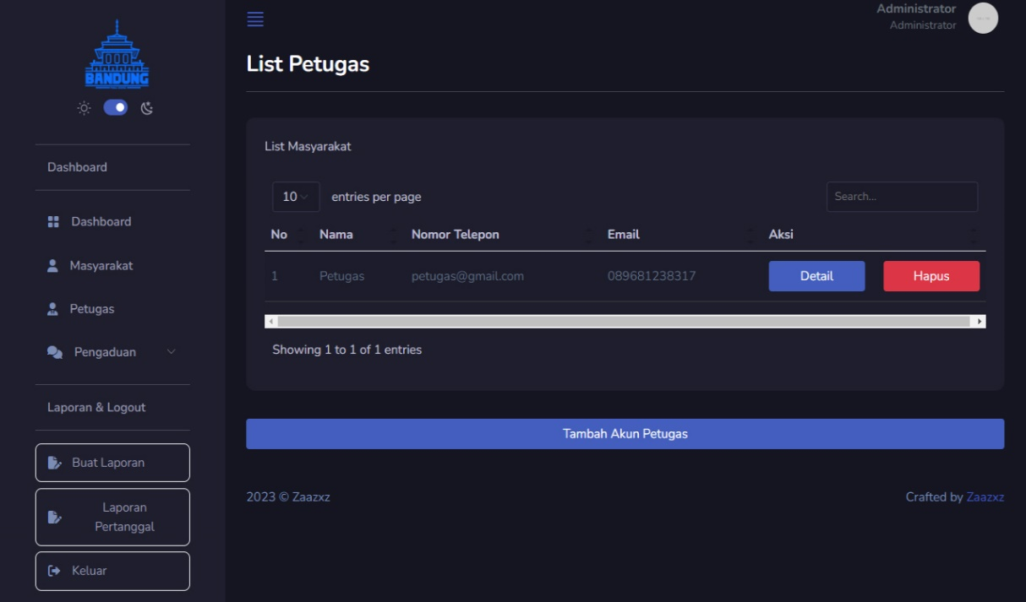

1. Halaman Management Masyarakat (Administrator)

